JichenDai_HW2

Build a Convolutional Neural Network

Accuracy = 0.9736

Normalization Plot:
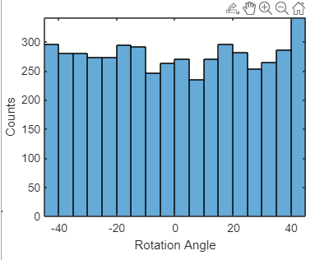

Training process plot:
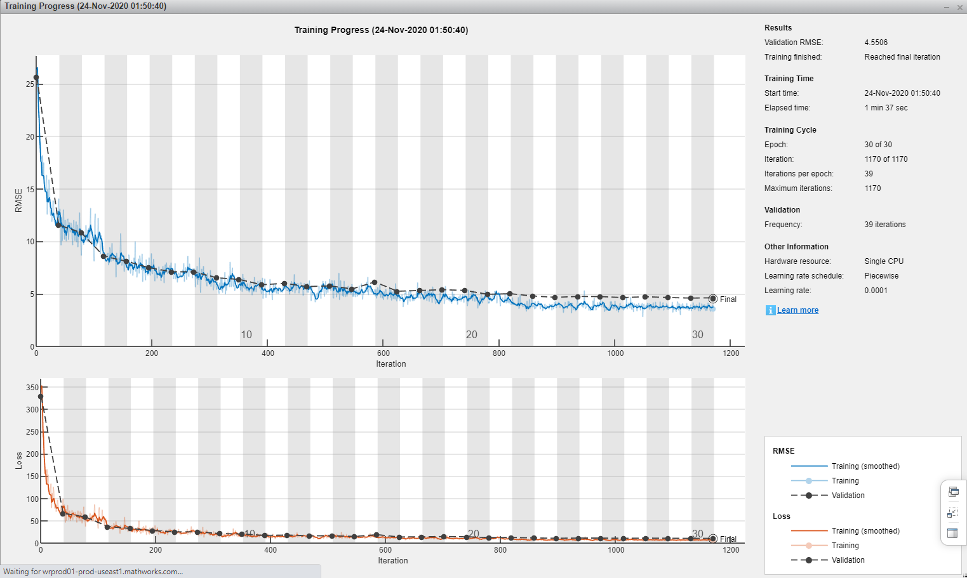
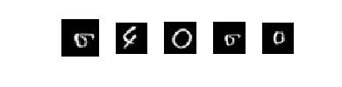
Five Worst predicted samples

Why failed predict these samples:
Because these 6s and 0s are too similar, the tails of these 6's are not obvious, like a scribbled 0.
For this 4, I think it is because the upper open is too big, don’t like a normal 4.

